Item No: | 1
Pole No: | 250658
Location: | ALONG POBLACION, TACURONG CITY, SULTAN KUDARAT, BESIDE EATERY
 | MIN862 NAP MAX PROJECT
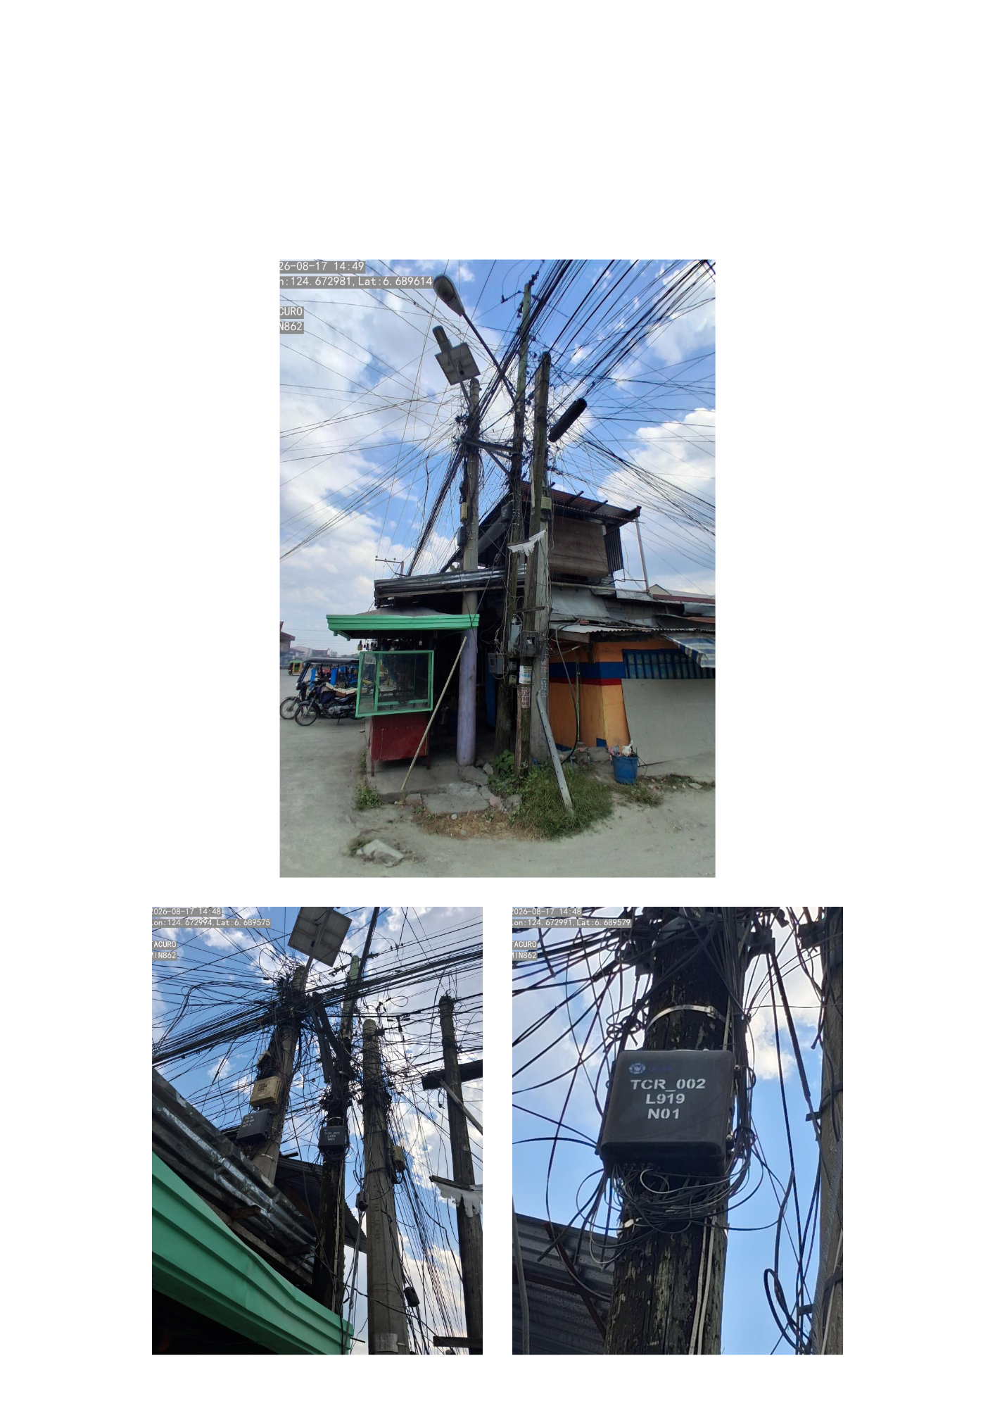

Item No: | 2
Pole No: | NPT
Location: | ALONG SAN PABLO, TACURONG CITY, SULTAN KUDARAT, BESIDE STORE
 | MIN862 NAP MAX PROJECT
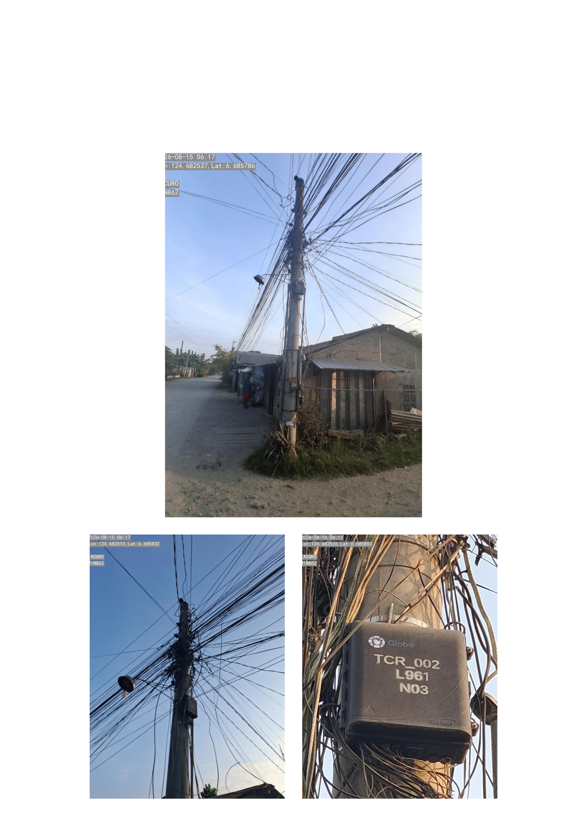

Item No: | 3
Pole No: | 251594
Location: | ALONG BRGY RD., TACURONG CITY, SULTAN KUDARAT, BESIDE VL
 | MIN862 NAP MAX PROJECT
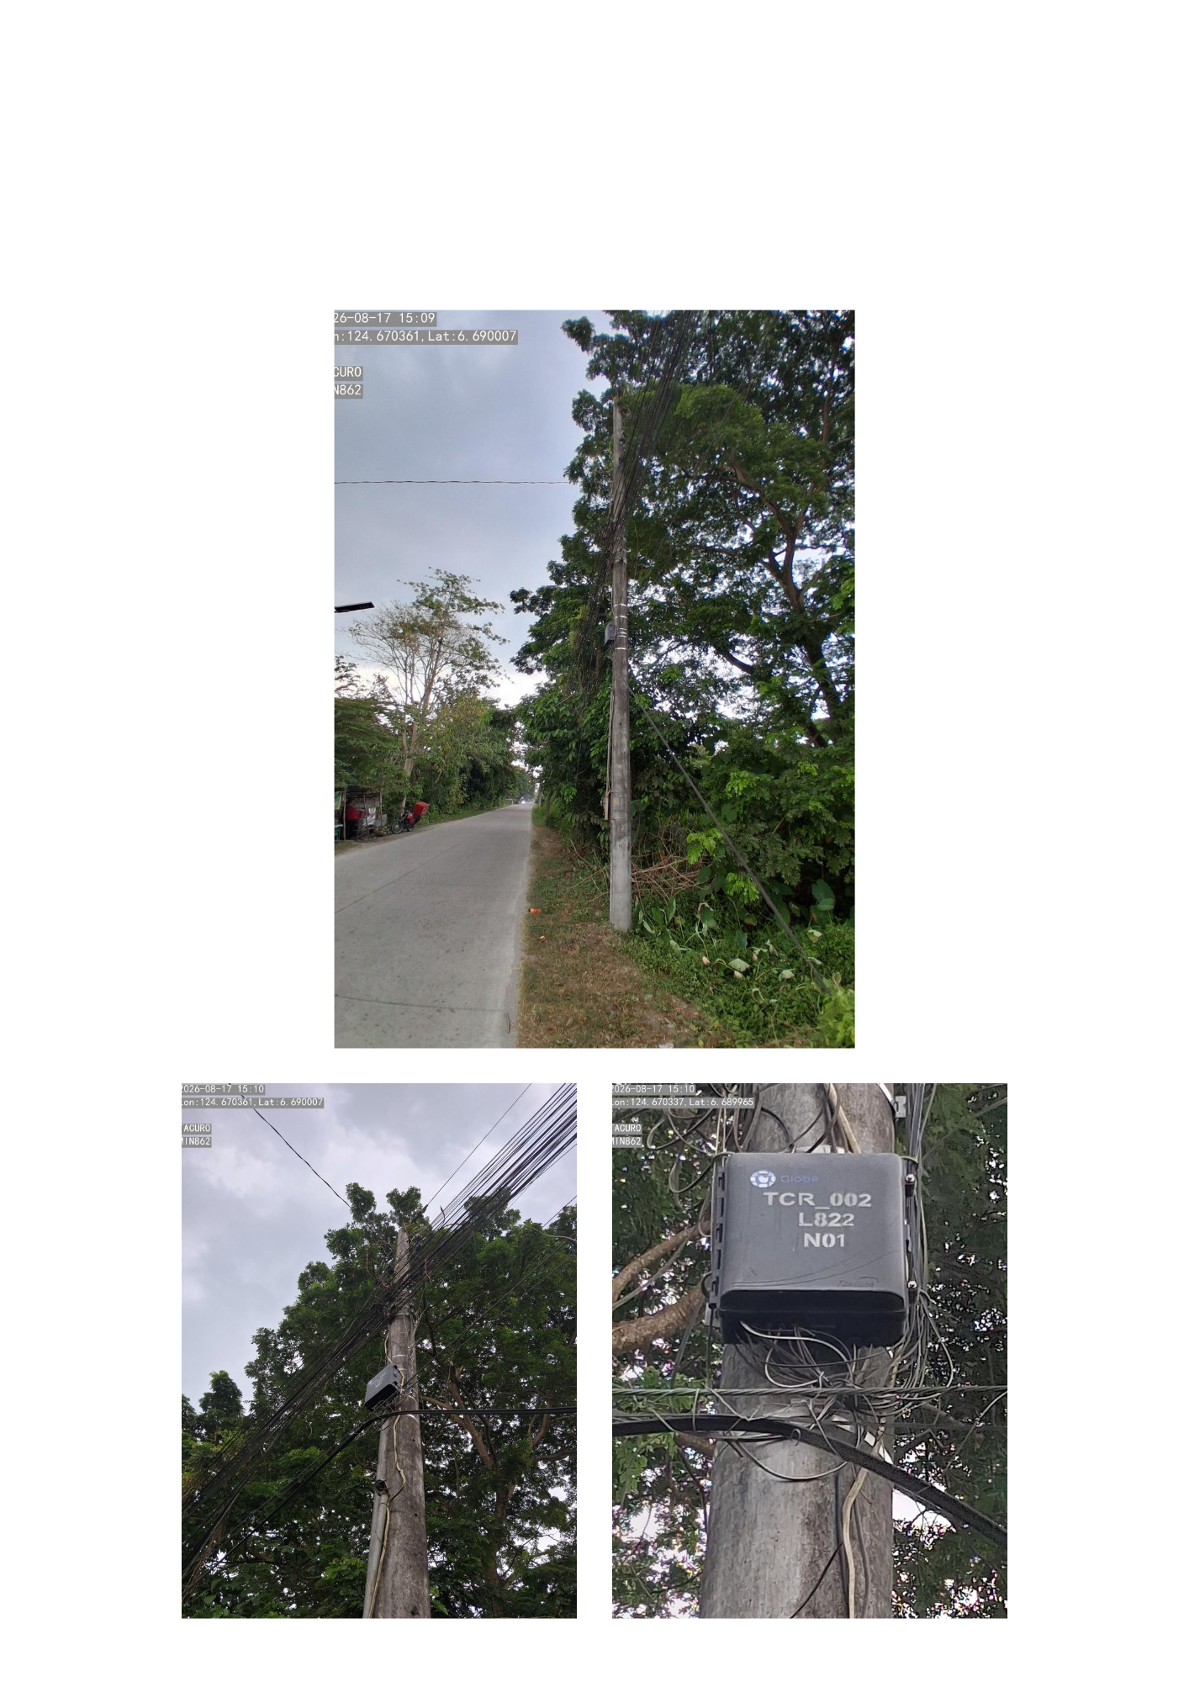

Item No: | 4
Pole No: | NPT
Location: | ALONG NEW ISABELA, TACURONG CITY, SULTAN KUDARAT, BESIDE EATERY
 | MIN862 NAP MAX PROJECT
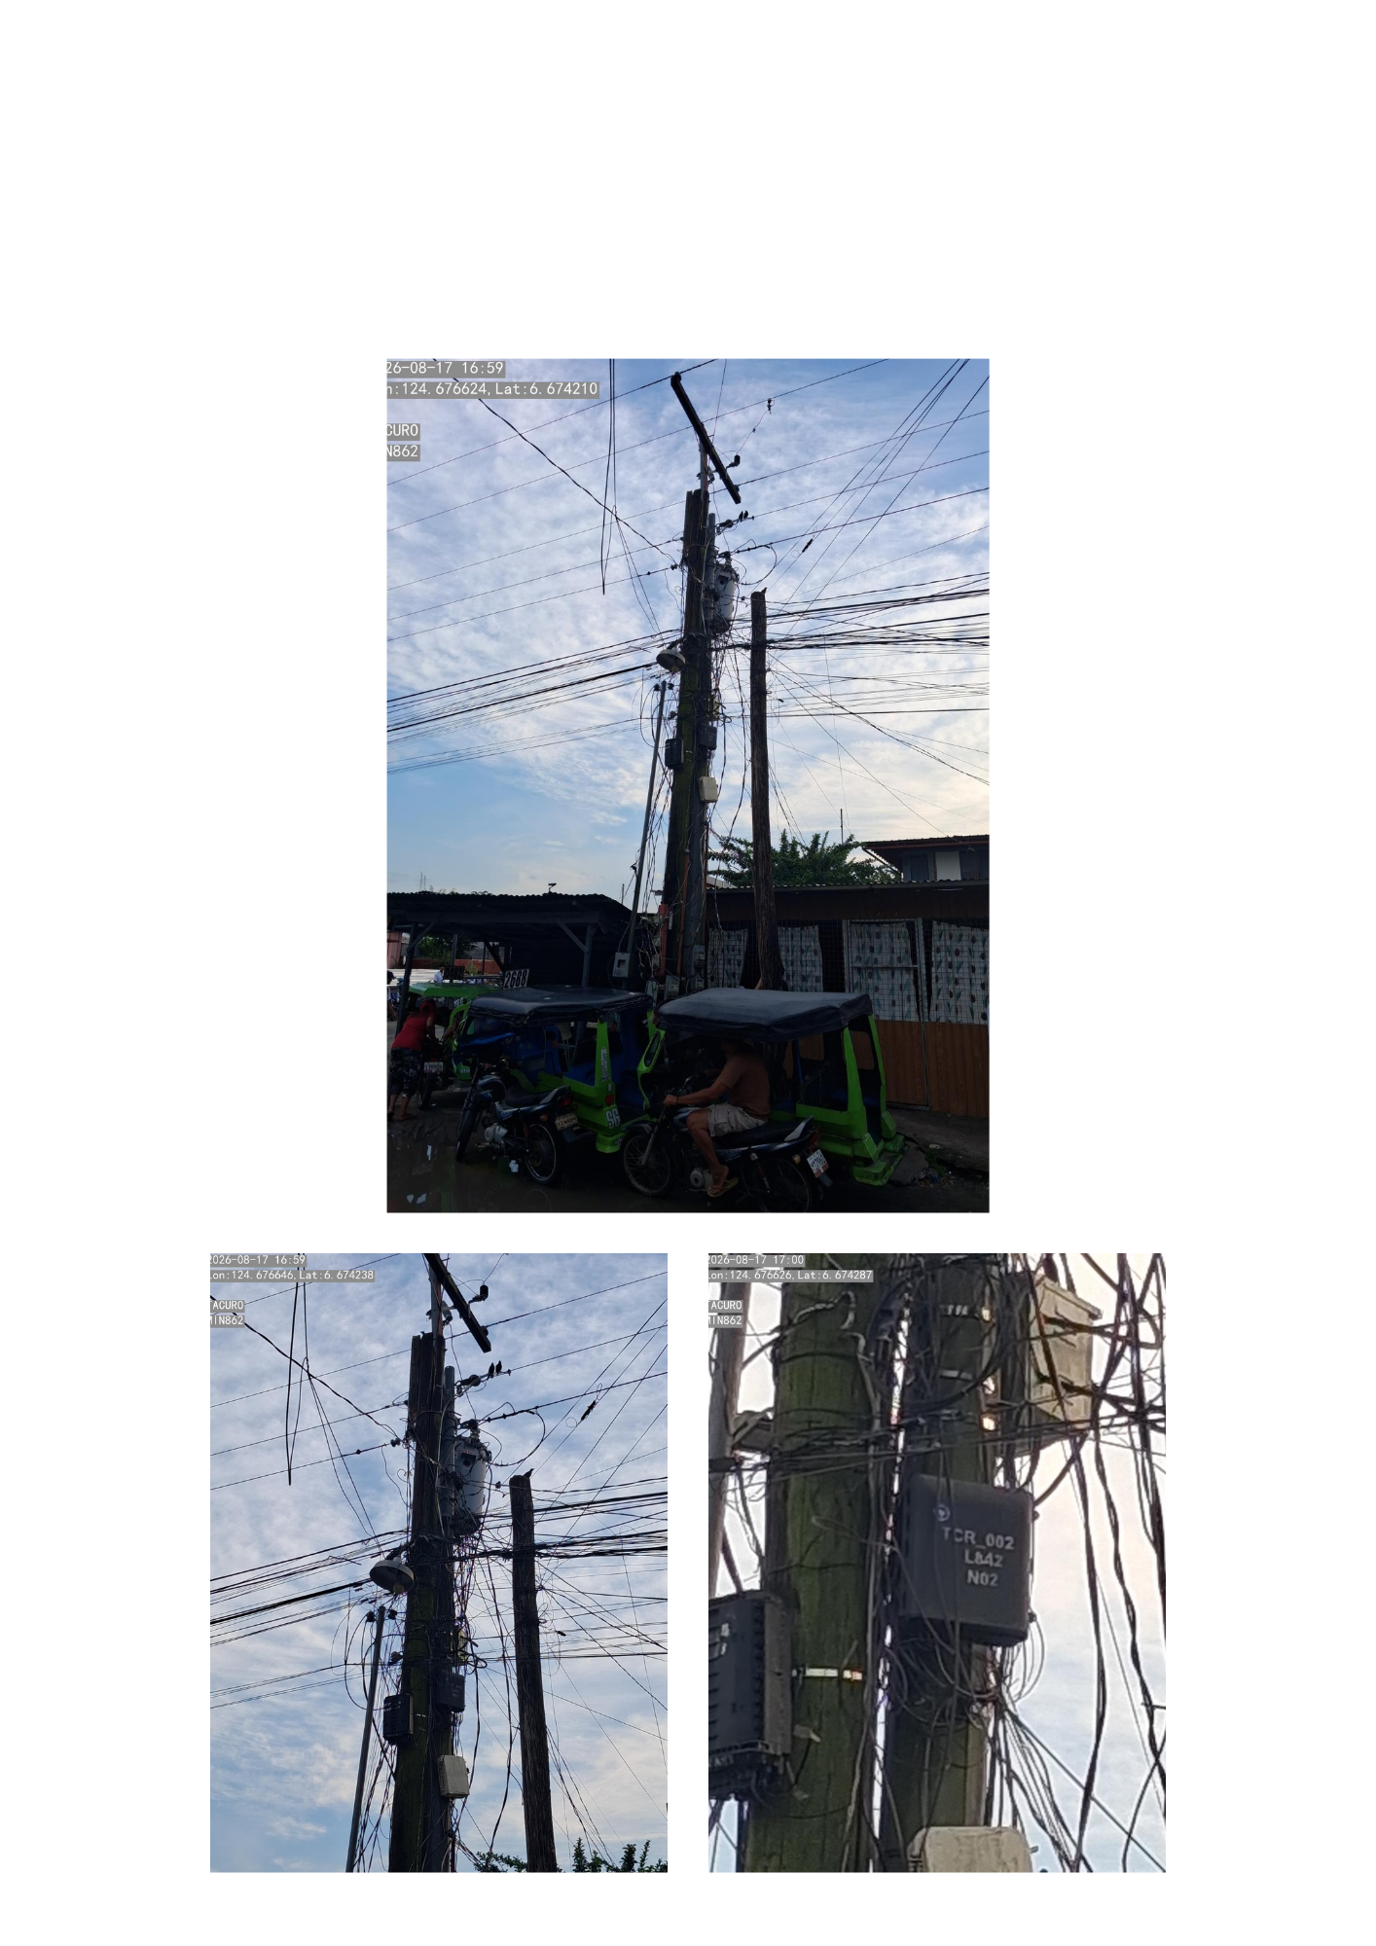

Item No: | 5
Pole No: | NPT
Location: | ALONG NEW ISABELA, TACURONG CITY, SULTAN KUDARAT, BESIDE STORE
 | MIN862 NAP MAX PROJECT
